**Analyze the WSDL and provide the information requested**

**Estimated Completion Time: 2 hours**

**Problem Statement:**

To analyze the WSDL and perform one operation completely to find the request and response XML tags with their data types.

**Steps to execute:**

Given the WSDL, [**http://www.gcomputer.net/webservices/dilbert.asmx?WSDL**](http://www.gcomputer.net/webservices/dilbert.asmx?WSDL) analyze and produce the following information:

1. Name of the Service described by this WSDL

ANS:

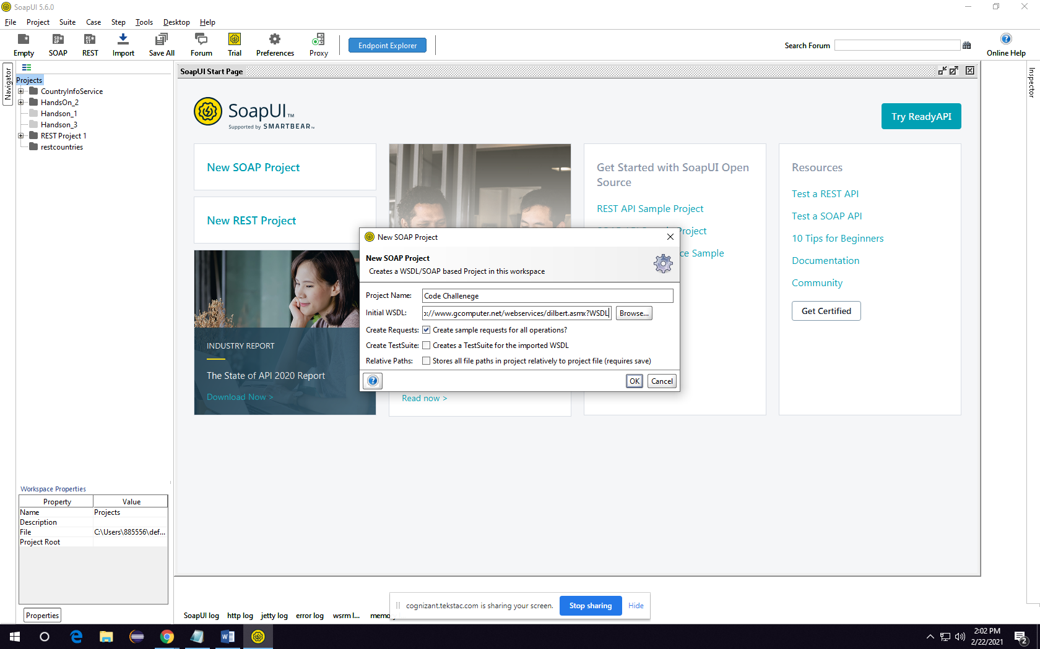

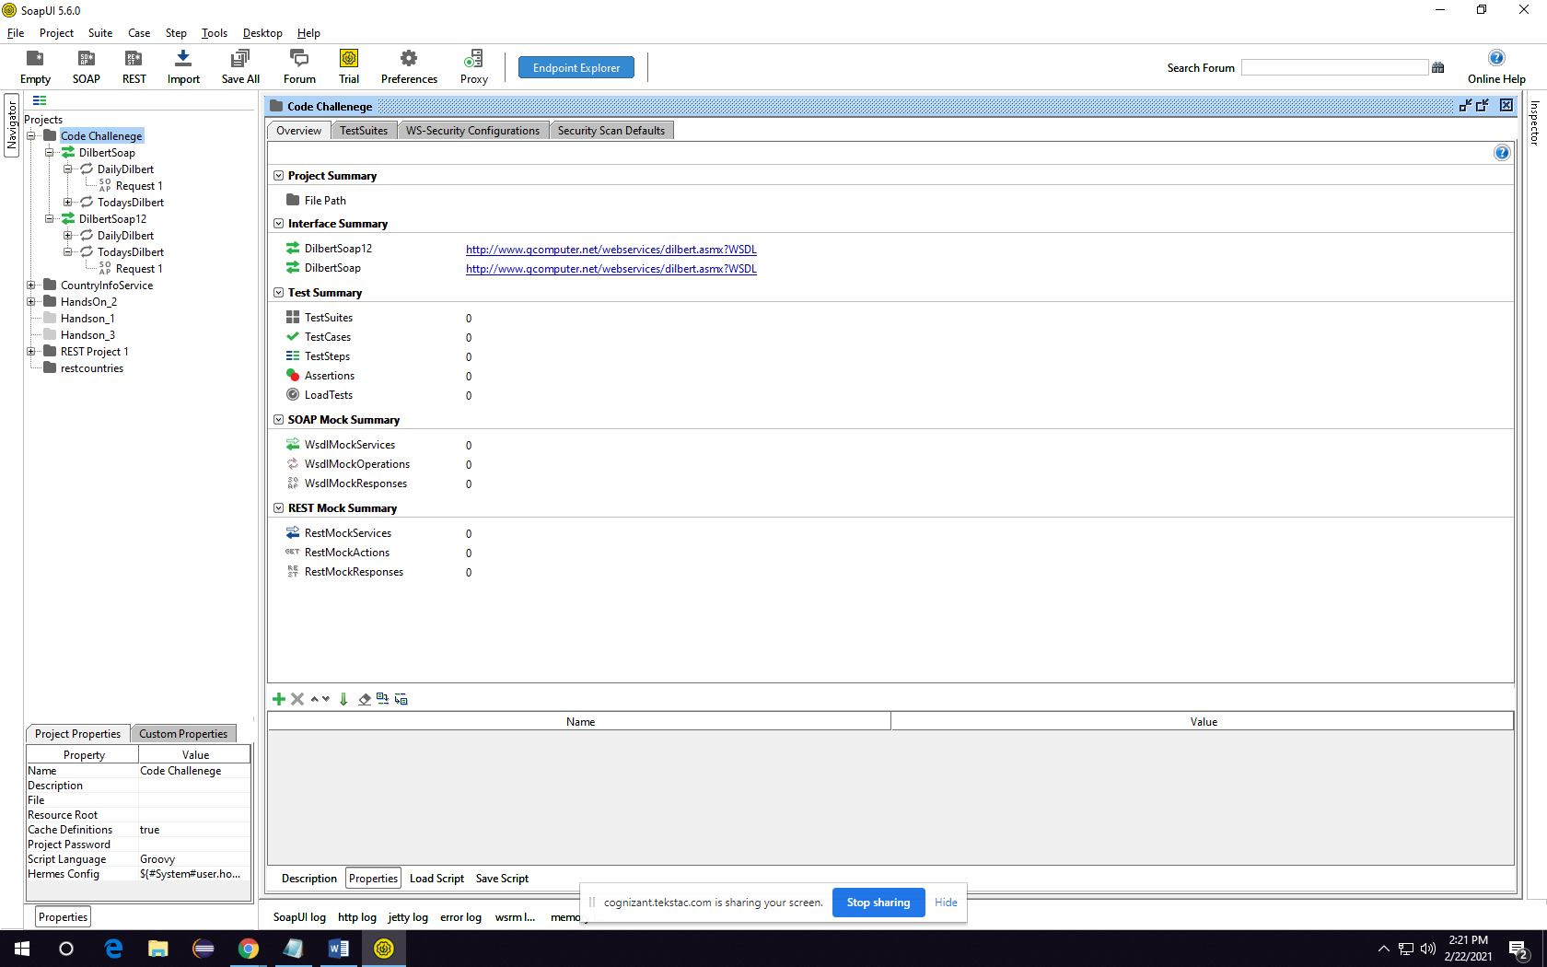

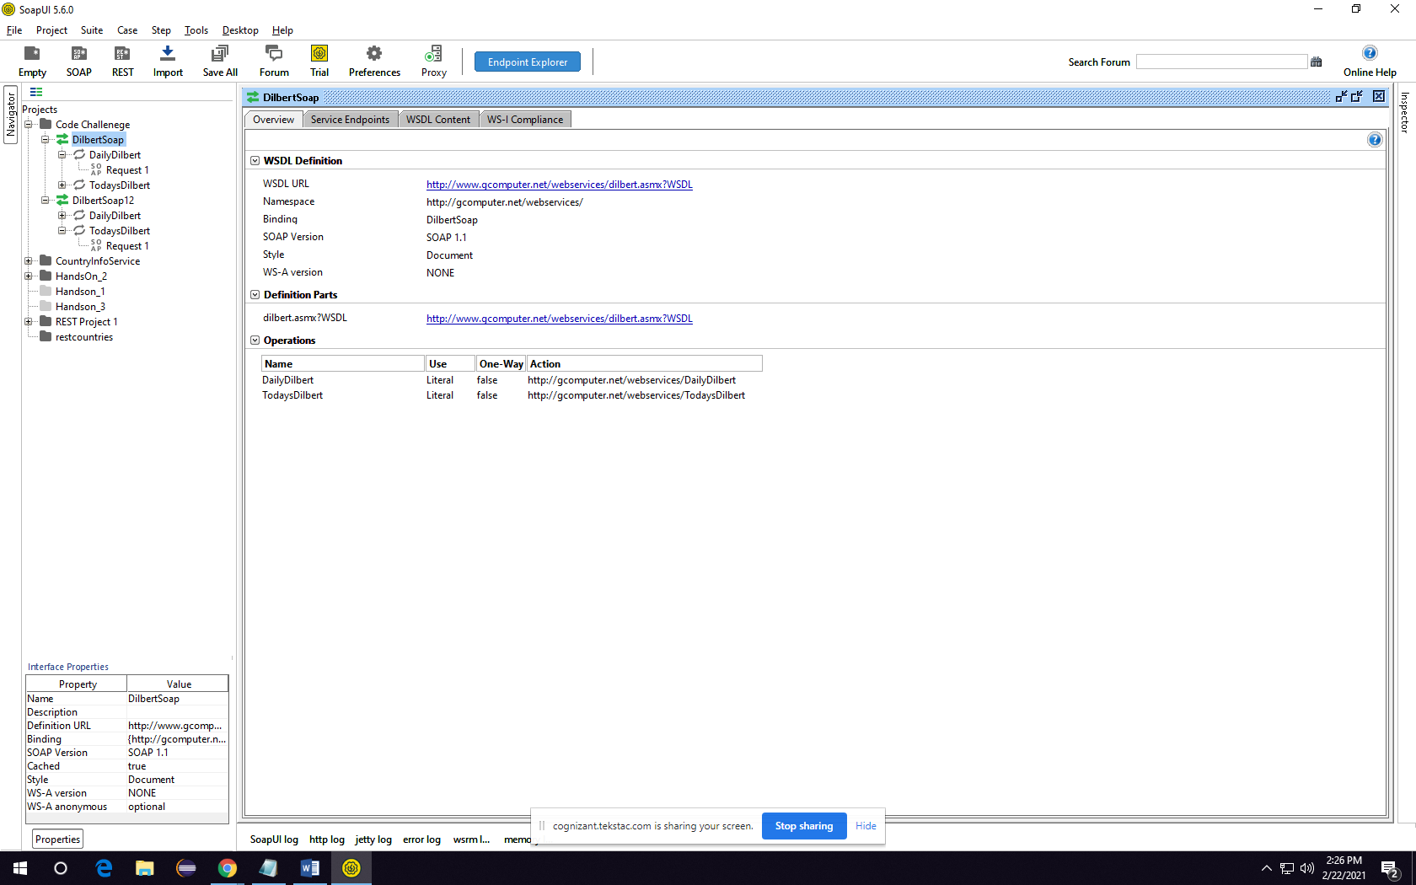

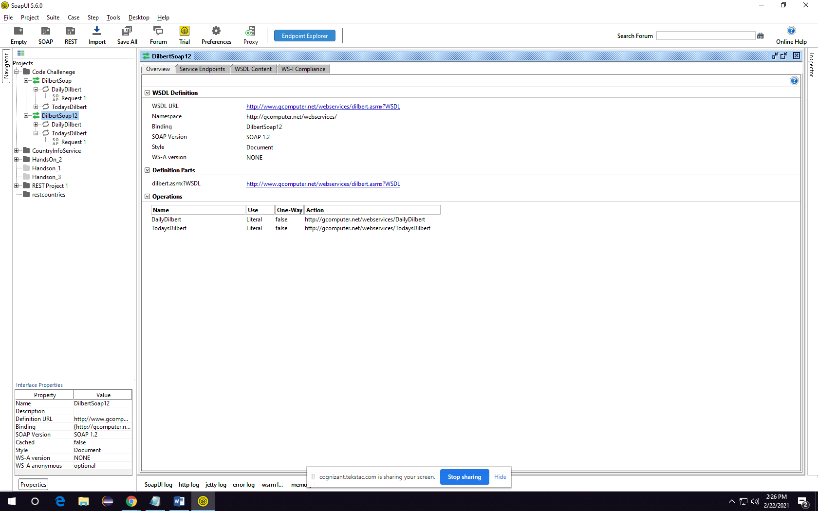

1. Extract the endpoint for this service

ANS: 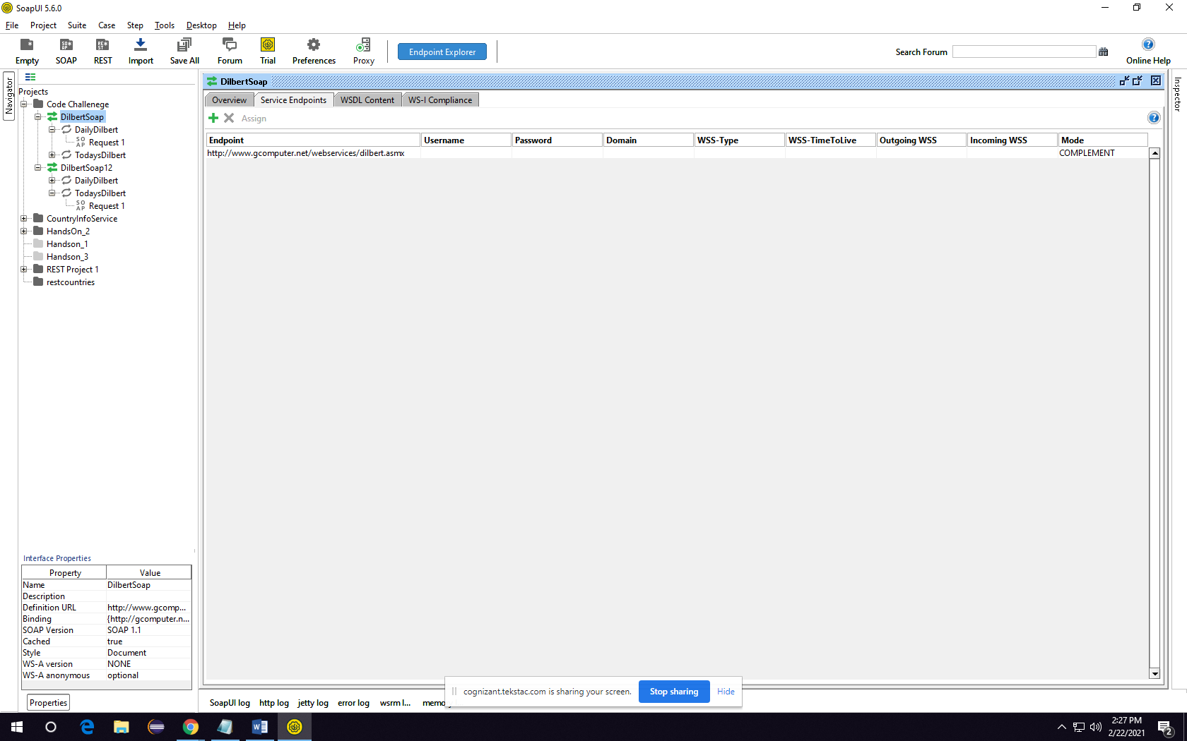

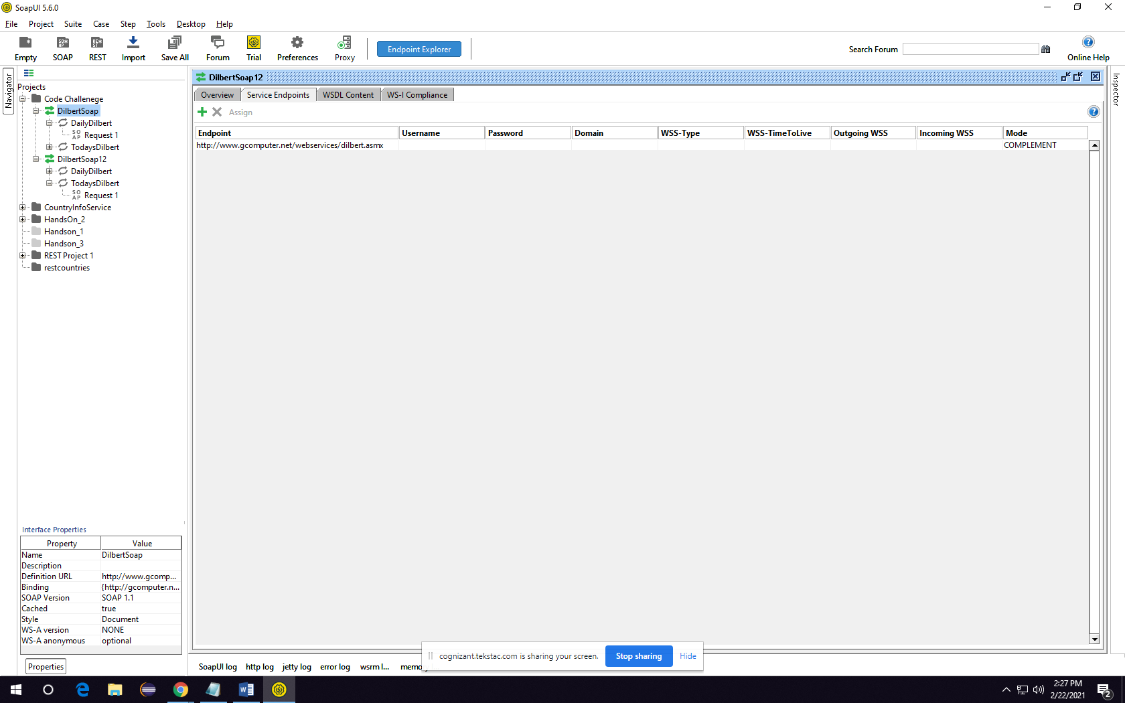

1. List the count and name of the operations provided by this service

ANS: 



4. Find the request and response XML tags with their data types, for at least one operation completely

ANS: 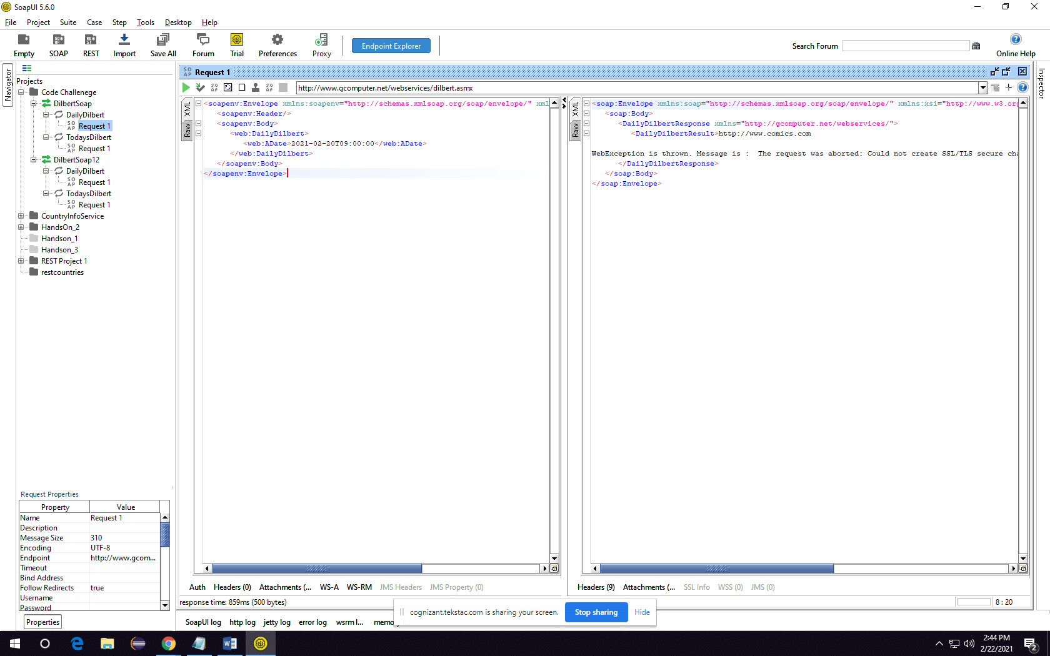

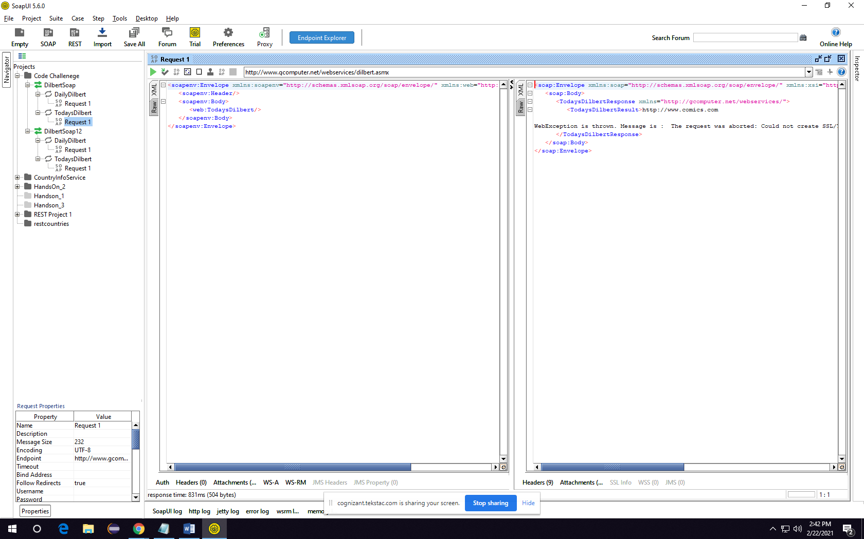

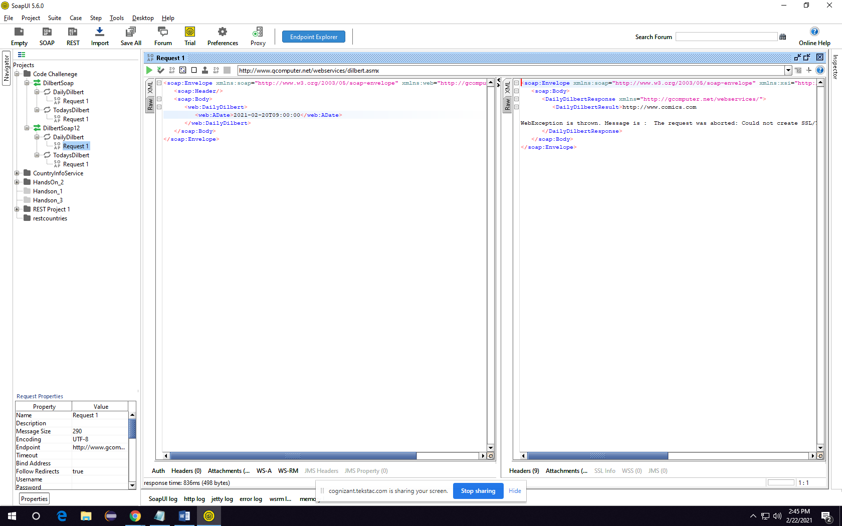

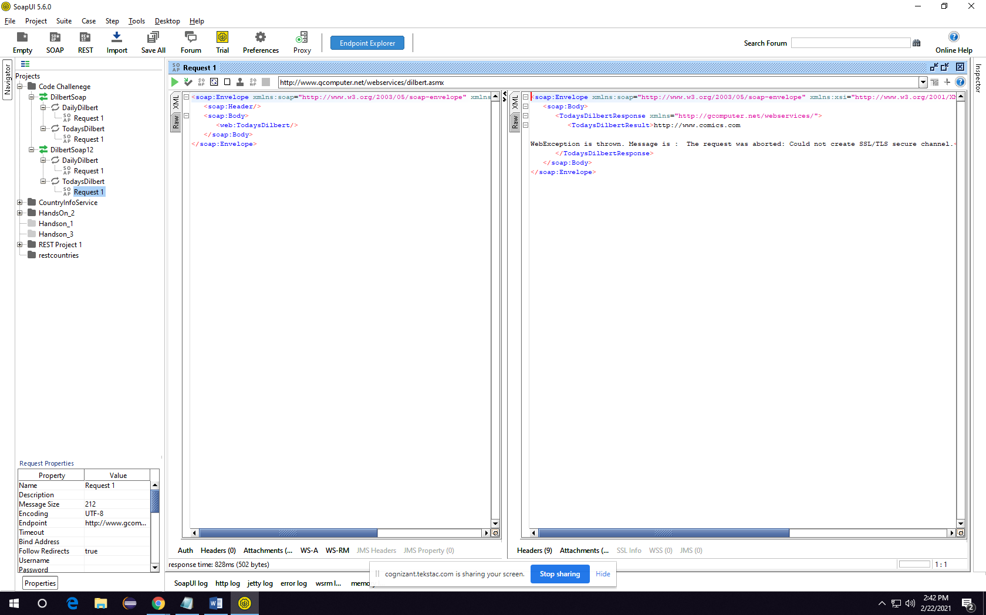

The Element of Request is:

<s:element minOccurs="1" maxOccurs="1" name="ADate" type="s:dateTime"/>

Name = ADate

Type = s:dateTime

The Element Of Response is:

<s:element minOccurs="0" maxOccurs="1" name="DailyDilbertResult" type="s:string"/>

Name: DailyDilbertResult

Type: s:string



